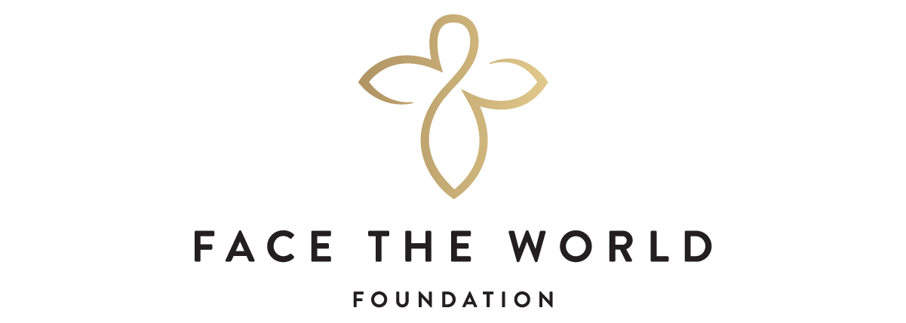

FACE THE WORLD FOUNDATION
FUNDING MANDATE AND APPLICATION PROCESS 2022

- Face the World Foundation provides grants to Registered Canadian Charities only, under the Income Act [Canada].

- Particular focus is given to non-profit organizations in the Greater Vancouver and Lower Mainland areas, although any charity operating in British Columbia that meets our giving guidelines, may apply.

- Please provide a one-page cover letter with your application, outlining your program’s objectives and the amount requested. Please do NOT include FTW instruction pages [1 - 3].

- If your program falls within Face the World Foundation’s funding mandate and giving guidelines, please submit your application, cover letter and required attachments via email to: info@facetheworldfoundation.com

Subject: 2022 Recipient Grant Application
Attention to: The Selection Committee

- Organizations are to submit their application prior to this year’s Deadline of October 15, 2022.

6. If applying by mail, please send to the following address, attention to:
The Selection Committee
c/o Face The World Foundation
74 West Cordova Street
Vancouver, BC
V6B 1C9

Inquiries : Monday - Friday 8:30 am - 5:00 pm
Phone : (778) 837-8907

FACE THE WORLD FOUNDATION

GIVING GUIDELINES

a) to relieve poverty by providing counselling and financial, physical and educational assistance to those in need and to increase public awareness of the problems of those living in poverty;

b) to provide shelter to the homeless or the dispossessed and to increase public awareness of the problems of the homeless and the dispossessed;

c) to provide refuge, shelter, counselling and other assistance to men, women and children who have been victims of domestic violence or abuse, including sexual abuse, and to increase public awareness of the problems faced by such persons;

d) to foster public awareness of our environment and the dangers that threaten our land, air, water, wildlife and fauna and to educate the public about ways in which these dangers can be reduced or eliminated;

e) to advance education by establishing and maintaining advanced and continuing education programs for deserving individuals, by providing grants and scholarships for the purpose of study and research, by providing endowments to institutions of higher learning, by sponsoring public lecture programs, by funding visiting professorship programs, and by conducting and organizing symposia, educational courses, seminars, conferences and discussion forums;

f) to promote health by conducting and sponsoring medical research, by building and maintaining hospitals and community medical clinics, and operation of hospitals and clinics;

g) to give assistance, both financial and nonfinancial, to other organizations for the purpose of supporting charitable programs and charitable activities that are compatible with the objects of the Foundation;

h) to raise funds for the purposes of the Foundation through community appeals for funds and by receiving gifts, donations, legacies, bequests, memorial funds, endowments, and similar gratuitous dispositions of money.

FACE THE WORLD FOUNDATION
PROCEDURES FOR APPLICANTS

All proposals should be submitted on the attached Face The World Foundation forms. Supplemental information of no more than three (3) pages, plus budgets and/or other financial information may be included.

REQUIRED ATTACHMENTS

- Top line Organization Budget for current and fiscal year;
- Itemized list of sources of revenue for current fiscal year - individuals, foundations, corporate, government;

- Budget and revenue sources specific to the Program/Grant Request;
- List of Board of Directors and their professional affiliations;
- Registered Charitable Status and Charitable Registration Number [issued by Canada Revenue Agency (CRA)]; guidance below if required;
  - Visit CRA’s Charity Listings and enter your organization’s name
  - Select your organization from the suggested list and “Download Results”

Questions concerning the application may be emailed directly to info@facetheworldfoundation.com

OPPORTUNITY TO MEET WITH THE SELECTION COMMITTEE

Appointments are made at the discretion of the Selection Committee, as necessary, with the principals of the applicant’s organization and/or board members.

FACE THE WORLD FOUNDATION APPLICATION FORM

APPLICANT’S CONTACT INFORMATION

Name of Organization

________________________________________________________________________

Registered Charitable Number: ___________________________

Address __________________________________________________________________

City ___________________________ Postal Code ________________________
Contact Person: ____________________________________________
Phone _________________________ Ext ______________________

Email ________________________________________

FUNDING INFORMATION
Cheque to be issued to: ________________________________________________________________________ Contact Person for receipt of cheque & tax receipt (if different from above): ________________________________________________________________________
Phone #: ____________________________ Ext: ____________
Email: ______________________________

FACE THE WORLD FOUNDATION APPLICATION FORM
GRANT REQUEST

Project Budget (Specific to the Program, not the Organizational Budget)

$

Amount Requested

$

Percentage of Amount Requested to Project Budget

%

      - Period of Project

      - NEW Project or date created:__________________________________________

3. Description of Program and Objectives

FACE THE WORLD FOUNDATION APPLICATION FORM
ADMINISTRATIVE AND FISCAL DATA

1. Organization Budget, current fiscal year ending 20 $

2. Organization Budget, previous fiscal year ending 20 $

3. Number of paid staff Full time Part time

4. Salaries of the three top staff personnel per annum [examples below]

Position Amount

(a) Executive Director $

(b) Manager $

(c) Administrator [Other] $

5. Revenue Current Fiscal Year 20 Prior Fiscal Year 20

Amount % of Revenue Amount
Government: ___________ ____________________

Private: ___________ ____________________

FACE THE WORLD FOUNDATION APPLICATION FORM
BUDGET FOR GRANT REQUEST - INCOME SUMMARY

Private Sources of Funding

Foundations $

Individuals $

Corporations $

Other (specify) $

TOTAL PRIVATE REVENUE $

Government Sources of Funding - grants and contracts (specify)

$

TOTAL GOVERNMENT REVENUE $

*Note: In-kind contributions are not considered as income

OPERATING EXPENSES

Personnel (salaries, taxes, employee benefits) $
Occupancy costs Rent/Mortgage $
TOTAL OPERATING BUDGET $

I hereby certify that information contained in this proposal is correct and true. Digital signatures are accepted.

Signature of Executive Director Date

Print Name

Signature of President/Chair of Charity’s Board of Directors Date

Print Name

