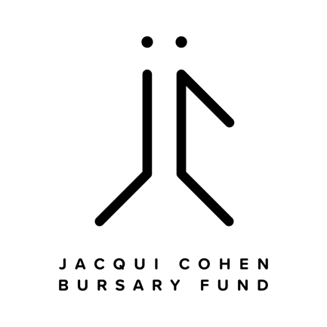

Full Name: Phone Number:
Street Address:
City:
Province:
Postal Code:
Birthdate (MM/DD/YYYY):

The following fields can be submitted in a separate document or piece of paper. Please ensure the documents are labelled accordingly. Alternatively, application form can be opened with Microsoft Word or Adobe Acrobat and filled out electronically.

1.) PROGRAM INFORMATION: Please tell us about the training or study program that you are planning to attend with the help of this bursary - what is the program, how long does it last, where does it take place, what skills or certification will you gain when you complete the program?

2.) ESSAY PROMPT: Please write a short essay describing your financial need and/or barriers to education/employment. How will this bursary help you meet your goals? How would receiving the bursary make a difference to you? How have you experienced barriers to employment in the past?

3.) BUDGET: Please outline the cost of the program and any supplies you will need, including cost of transportation (transit pass) if need to get to/from the program location and any applicable taxes.
*Please note we are unable to support Masters Programs or repayment of student loans.

4.) REFERENCE: Please attach a letter from a personal or professional reference.

5.) CONSENT: By checking YES this form, I authorize the Face The World Foundation to contact me for more information and to use the personal information provided on this form to make and communicate decisions about scholarship awards.
YES

Application form and supporting documents should be submitted by email with subject line — Jacqui Cohen Bursary Fund — to: info@facetheworldfoundation.com

Or mail to:
Jacqui Cohen Bursary Fund
c/o Face The World Foundation
74 West Cordova Street
Vancouver, BC
V6B 1C9

