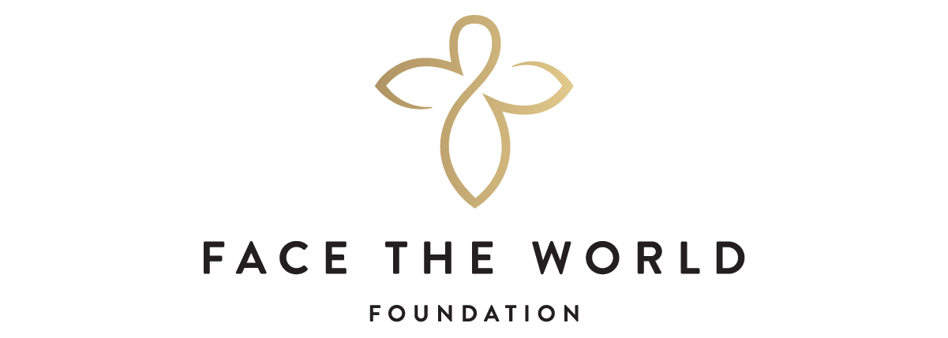

FACE THE WORLD FOUNDATION
FUNDING MANDATE AND APPLICATION PROCESS
Please note $5,000 maximum request for 2021

- Face the World Foundation provides grants to Registered Canadian Charitable Organizations only.

- Particular focus is given to non-profit organizations in the Greater Vancouver and Lower Mainland areas, although any charity operating in British Columbia that meets our giving guidelines, may apply.

- We do not require a letter of interest in order to apply for funding. We do ask that you provide a brief, one-page cover letter with your application, outlining your program’s objectives and the amount requested.

- If your program falls within Face the World Foundation’s funding mandate and giving guidelines, please submit your application, cover letter and required attachments via email to: info@facetheworldfoundation.com

Subject: 2021 Recipient Grant Application
Attention to: The Selection Committee

- Organizations submitting their application prior to this year’s Deadline of October 15, 2021 will typically receive a decision via letter by November 1st.

6. If applying by mail, please send to the following address, attention to:
The Selection Committee
c/o Face The World Foundation
74 West Cordova Street
Vancouver, BC
V6B 1C9

Inquiries : Monday - Friday 8:30 am - 5:00 pm
Phone : (778) 837-8907

FACE THE WORLD FOUNDATION

GIVING GUIDELINES

a) to relieve poverty by providing counseling and financial, physical and educational assistance to those in need and to increase public awareness of the problems of those living in poverty;

b) to provide shelter to the homeless or the dispossessed and to increase public awareness of the problems of the homeless and the dispossessed;

c) to provide refuge, shelter, counseling and other assistance to men, women and children who have been victims of domestic violence or abuse, including sexual abuse, and to increase public awareness of the problems faced by such persons;

d) to foster public awareness of our environment and the dangers that threaten our land, air, water, wildlife and fauna and to educate the public about ways in which these dangers can be reduced or eliminated;

e) to advance education by establishing and maintaining advanced and continuing education programs for deserving individuals, by providing grants and scholarships for the purpose of study and research, by providing endowments to institutions of higher learning, by sponsoring public lecture programs, by funding visiting professorship programs, and by conducting and organizing symposia, educational courses, seminars, conferences and discussion forums;

f) to promote health by conducting and sponsoring medical research, by building and maintaining hospitals and community medical clinics, and operation of hospitals and clinics;

g) to give assistance, both financial and non financial, to other organizations for the purpose of supporting charitable programs and charitable activities that are compatible with the objects of the Society;

h) to raise funds for the purposes of the Society through community appeals for funds and by receiving gifts, donations, legacies, bequests, memorial funds, endowments and similar gratuitous dispositions of money.

FACE THE WORLD FOUNDATION
PROCEDURES FOR SUBMITTING GRANT PROPOSALS

All proposals should be submitted on the attached Face The World Foundation forms. Supplemental information of no more than three (3) pages, plus budgets and/or other financial information may be included. If you are requesting support for more than one project, please use a separate application for each program.

REQUIRED ATTACHMENTS

- Line Item Organization Budget for current and fiscal year;
- Itemized list of sources of revenue for current fiscal year - individuals, foundations, corporate, government, churches, fees for service;

- Line item budget and revenue sources specific to the Program/Grant Request;
- List of Board of Directors and their professional affiliations;
- Affiliation with churches, denominations and associations;
- Registered Charitable Status;
  - Visit CRA’s Charity Listings and enter your organization’s name
  - Select your organization from the suggested list and “Download Results”
  - A file will automatically download. Include the file titled, “Charities_Results.txt” in the final email when submitting, or print and include with your application, if sending by mail.

Questions concerning the application may be emailed directly to info@facetheworldfoundation.com

MEETING OPPORTUNITIES WITH THE SELECTION COMMITTEE

Appointments are made at the discretion of the Selection Committee, as necessary, with the principals of the applicant’s organization and/or board members.

FACE THE WORLD FOUNDATION APPLICATION FORM

CONTACT INFORMATION

Name of Organization

Registered Charitable Number

Address _

City ______________ Postal Code
Contact Person: ________________________________________________
Phone ___________________________ Ext ___ __________

Email

FUNDING INFORMATION
Cheque to be issued to (if different from above Organization Name)
Contact Person for issuing cheques & tax receipts (if different from above) ________________________________________________________________________
Phone #: _____________________________________ Ext: ____________
Email: ___________________________________________________________________

FACE THE WORLD FOUNDATION APPLICATION FORM
GRANT REQUEST
Please note $5,000 maximum request for 2021
Project Budget (Specific to the Program, not the Organizational Budget)

$

Amount Requested

$

Percentage of Amount Requested to Project Budget

$

1. Period of Project

2. Program Objectives (include schedule of accomplishments)

FACE THE WORLD FOUNDATION APPLICATION FORM

3. Results or status to date

4. Expected results (immediate, long-range)

FACE THE WORLD FOUNDATION APPLICATION FORM

5. What is your fund-raising strategy for this project?

- How will this project be funded after the requested grant is expended?

- Evaluation process -- How will results be determined and measured?

FACE THE WORLD FOUNDATION APPLICATION FORM
ADMINISTRATIVE AND FISCAL DATA

1. Organization Budget, current fiscal year ending 20 $

2. Organization Budget, previous fiscal year ending 20 $

3. Number of paid staff Full time Part time

- Volunteer hours contributed during last fiscal year and number of people

5. Salaries of the three top staff personnel per annum

Position Amount

(a) Executive Director $

(b) Manager of Family and Seniors Programs $

(c) Administrator $

6. Revenue Current Fiscal Year 20 Prior Fiscal Year 20

Amount % of Revenue Amount % of Revenue
Government:
Private:

FACE THE WORLD FOUNDATION APPLICATION FORM
BUDGET FOR GRANT REQUEST - INCOME SUMMARY
Please see Appendix A for Budget Details
Private Sources

Foundations $

United Way $

Investment Income $

Fund-raising projects $

Individuals $

Corporations $

Fees $

Other (specify) $

TOTAL PRIVATE REVENUE $

Government - grants and contracts (specify)

$

TOTAL GOVERNMENT REVENUE $

FACE THE WORLD FOUNDATION APPLICATION FORM
BUDGET FOR GRANT REQUEST (IF APPLICABLE) - OPERATING EXPENSES

Personnel (salaries, taxes, employee benefits) $
Professional services (legal, accounting) $
Occupancy costs Rent/Mortgage $
Utilities $
Total Occupancy Costs $
Office supplies, postage, couriers, printing $
Mobile Phones, Wi-Fi and Landlines $
Travel - Local $ Other $
Total Travel Costs $
Conferences, meetings $
Insurance $
Equipment costs $
Other (specify) $
Other (specify) $
TOTAL OPERATING BUDGET $

EXCESS OF INCOME (LOSS) OVER EXPENSES $

*Note: In-kind contributions are not considered as income

I hereby certify that information contained in this proposal is correct and true. Carbon Copy/Digital signatures are accepted.

Signature of Executive Director Date

Print Name

Signature of President/Chair of Charity’s Board of Directors Date

Print Name

Please note $5,000 maximum request for 2021

